HSM USB Serial Driver Addendum

|  |  |  |  |
| --- | --- | --- | --- |
| Reviewers | |  |  |
| Name | Function | Date | Signature |
| Wilz, Dave | Software Firmware | March, 2021 |  |
| Schuster, Dominik | Technical Sales | March, 2021 |  |
|  |  |  |  |
|  |  |  |  |
|  |  |  |  |
|  |  |  |  |
|  |  |  |  |
|  |  |  |  |
|  |  |  |  |

Revision History

| **Rev.** | **Date** | **Author** | **Description** |
| --- | --- | --- | --- |
| 1.0 | March, 2021 | Uday | Initial draft |
|  |  |  |  |
|  |  |  |  |
|  |  |  |  |
|  |  |  |  |
|  |  |  |  |

Table of Contents

1 Introduction 4

1.1 Purpose 4

1.2 Audience 4

2 History 4

3 Non Win10 Submission 5

4 Security Patches 6

5 Contact Information 7

# Introduction

This addendum describes the changes that are required at customer side for smooth installation of HSM USB Serial Driver version 3.5.23 onwards on non Win10 OS environments.

## Purpose

Define the role or purpose of the Software Architecture Description, in the overall project documentation, and identify the specific audiences for the document, with an indication of how they are expected to use the document.

This addendum provides a comprehensive overview of the security changes initiated by Microsoft, its impact on HSM USB Serial Driver component and the steps required at end user side to ensure smooth installation and working on non Win10 environments like Windows 7, POSReady7, etc.

## Audience

The intended audience are the end user who use HSM USB Serial Driver versions 3.5.23 and above on non Win10 platforms.

# History

Traditionally, for every new Honeywell scanner device model released, there will be corresponding version of HSM USB Serial Driver which needs to be installed on Windows host machine so that the applications can work with USB Serial emulation interface of the scanner device. Every new device model will have unique PID (product identifier) following the USB specification. The new PID value will be included in the serial driver, version is incremented, and the new driver package will be signed at Microsoft partner center.

The driver package will be bundled into the cab file and during the submission by default for new hardware, only Windows 10 digital signatures are available at Microsoft partner center. It includes all Windows 10 versions. The catalog files in the driver package will be signed with these signatures and hence the installation of the serial driver on Windows 10 will be smooth without any warning dialog prompts to the end user.

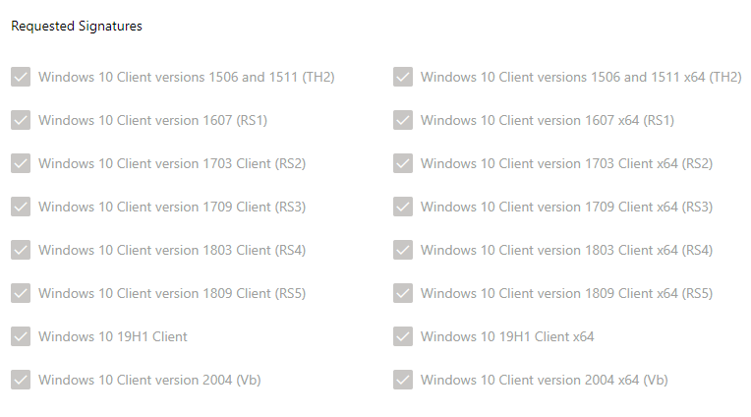

# Non Win10 Submission

Since there is no non Win10 driver submission the updated driver model needs to be signed using extended validation EV certificate as mentioned at <https://docs.microsoft.com/en-us/windows-hardware/drivers/dashboard/attestation-signing-a-kernel-driver-for-public-release>

There was a change in Microsoft driver signing policy and because of security vulnerabilities in sha1 signing procedure, only sha2 is supported now. For non Win10 legacy versions like Windows 7, etc. we need to use appropriate Hardware Certification Kit. All the tests that are suggested in HCK shall be completed and the new driver package shall be submitted so that the driver is signed by Microsoft for non Win10 platforms.

<https://docs.microsoft.com/en-us/windows-hardware/drivers/install/kernel-mode-code-signing-policy--windows-vista-and-later-#signing-requirements-by-version>

Once the driver version completes all HCK tests, and resultant package is signed by Microsoft, from next version onwards Driver Update Acceptable (DUA) process can be followed. For HSM USB Serial Driver version 3.5.23 we have completed all HCK suggested tests and resultant deliverable package has been signed by Microsoft for all non Win10 platforms.

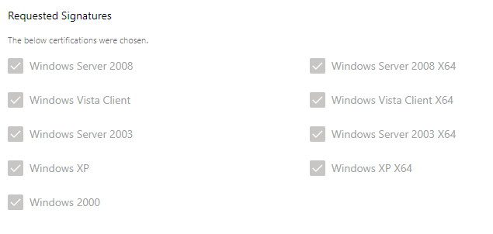

# Security Patches

Since the new driver packages will be signed by Microsoft using sha2 digest hash algorithm, the host environment shall have the support for the same. Pre Win10 OS versions do not have sha2 support and Microsoft has provided security patches for all non Win10 platforms which needs to be installed so that driver installation is smooth. Complete details on sha2 code signing support update for Windows 7 legacy OS flavors, etc. are available at <https://support.microsoft.com/en-us/topic/sha-2-code-signing-support-update-for-windows-server-2008-r2-windows-7-and-windows-server-2008-september-23-2019-84a8aad5-d8d9-2d5c-6d78-34f9aa5f8339>

We need to download and install following security patches from Microsoft Update Catalog for target OS accordingly and reboot the system. During installation, system needs to be connected to network. If Windows update feature automatically installed these updates means, no further action needs to be taken.

KB4474419 - <https://www.catalog.update.microsoft.com/Search.aspx?q=KB4474419>

KB4490628 - <https://www.catalog.update.microsoft.com/Search.aspx?q=KB4490628>

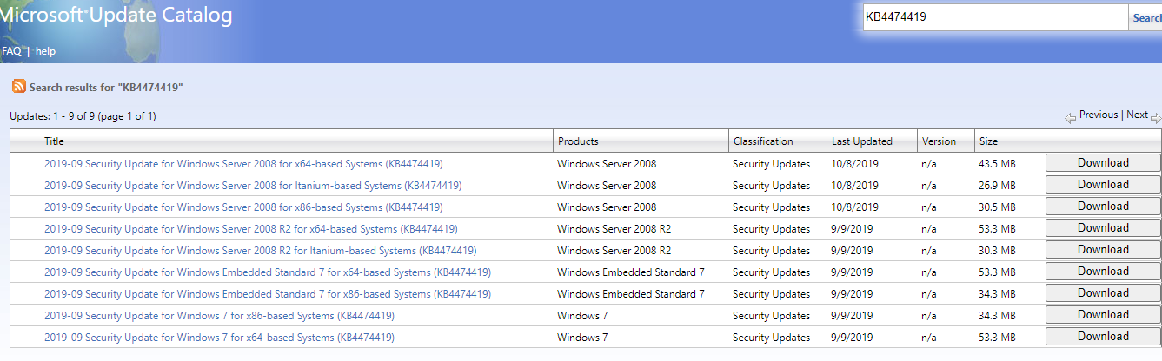

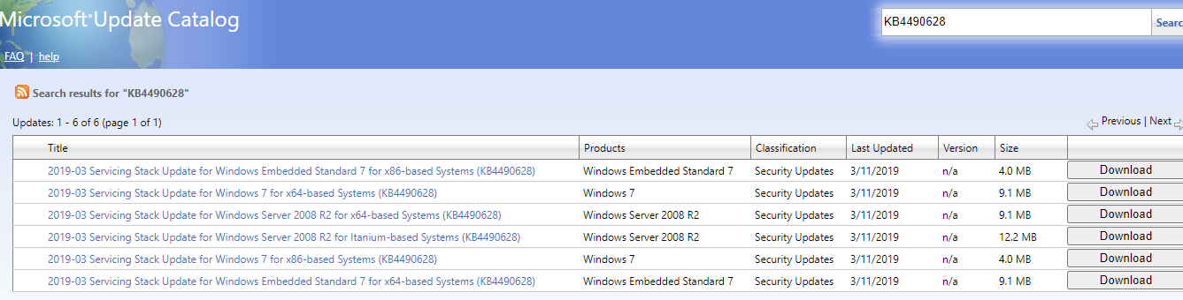

# Contact Information

Provide a general description of the software system including the major functions provided to the stakeholders. The purpose is to provide the reader with a consistent mental model of the system and its purpose.

For any further information and complete support, please contact below team members:

|  |  |  |  |
| --- | --- | --- | --- |
| Name | EID | Mail ID |  |
| Uday | E529330 | udaya.bhaskar@honeywell.com |  |
| Kavya | H441493 | kavya.s@honeywell.com |  |